AWS Cognito – Create User Pool

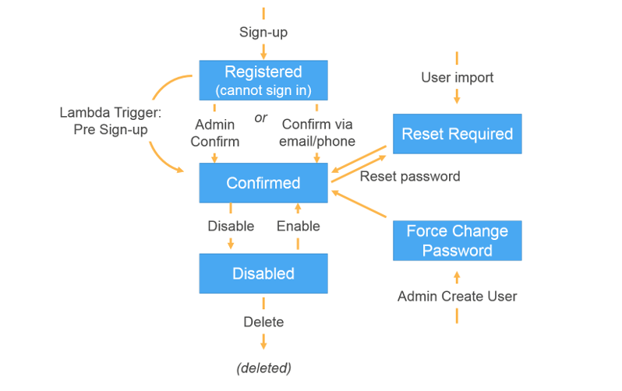

Add iVA-dasboard app to user Pool

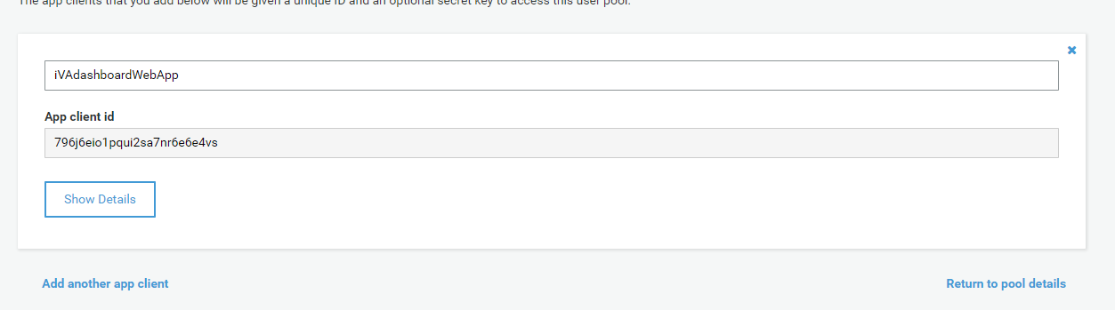

Pool Id

